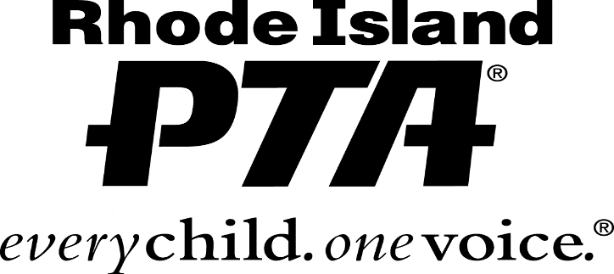
RI Congress of Parents and Teachers
P.O. Box 8476 • Warwick, RI 02888
• E-mail: president@rhodeislandpta.org/ •
• Website: www.rhodeislandpta.org/ •
• Sarah Theberge, President

Rhode Island PTA
LPL Scholarship Application
2021-2022

The LPL Scholarship was established by the Rhode Island PTA in honor of Lucille Putnam Leonard, a past State and National PTA President, to honor her memory for distinguished service to the Parent Teacher Association. The LPL Scholarship is supported by contributions from local PTA units, councils and friends of Rhode Island PTA. This award encourages and recognizes our youth as the next generation of volunteers, advocates, and difference-makers in the lives of children.

The award will be presented at the Rhode Island PTA annual meeting, the evening of April 28, 2022. Save the date!

General Guidelines for Application:
- All high school seniors currently attending a Rhode Island high school with a PTSA in good standing are eligible to apply. For information on joining your high school’s PTSA, please contact the PTSA President or the Rhode Island PTA President at presidentripta@gmail.com.
- Applicant must be a member of their high school PTSA prior to March 11, 2022.
- Applicant must plan to be enrolled full-time in an accredited college, university or a technical institute in the summer or fall semester immediately following high school graduation.
- Immediate family members of the LPL Scholarship Committee are not eligible to apply.
- Please submit document(s) in PDF format to riptasecretary@gmail.com.
- To qualify, the applicant must complete the application and include the following in their application packet:
- A resume, limited to one page, listing school activities, community involvement, special recognitions and awards the applicant received in high school. Also, list any work experience during the high school years.
- Copy of high school transcript (Does not need to be “Official”.)
- Responses to the questions below. Each response has a minimum and maximum word count.
- Describe your future goals for both your education and career. (150-300)
- Describe the role PTA has played in supporting and enriching your K-12 education. (150-300)

- Two letters of recommendation from any two of the following:
- Teacher/Guidance Counselor
- Employer/Supervisor/Scout Master/Mentor
- Personal reference
- All submissions…
- Must be in English.
- Must be legible, neat, and demonstrate the applicant’s best effort.
- Must be original work.
- Become property of Rhode Island PTA and will not be returned.
- Must be received by the submission date
- Return completed application and ALL additional documents to:
- Rhode Island Congress of Parents & Teachers, P.O. Box 8476, Warwick, RI 02888, Attn: LPL Committee
or
- Complete the form below and email the form and ALL additional documents to riptasecretary@gmail.com
- ALL COMPLETED applications must be POSTMARKED/SUBMITTED no later than March 11, 2022.

Selection and Disbursement:
Applications will be reviewed by the LPL Scholarship Committee in late March of 2022. Applicants may be asked for additional information. The awardee(s) will be notified and posted on the Rhode Island PTA website no later than April 28, 2022. All applicants will receive an email notification when the results have been posted. Awardee(s) must attend the Rhode Island PTA 2022 annual meeting to accept the scholarship. After providing proof of enrollment at an eligible institution, the awardee(s) may claim their disbursement no later than August 31, 2022. Awardee(s) will receive further instruction for submitting documentation for disbursement of funds. Checks will be written to the applicant’s institution of enrollment. Failure to meet the deadline will result in forfeiture of scholarship. Decisions of the LPL Scholarship Committee are final.

Rhode Island PTA
LPL Scholarship Application 2021-2022
Applicant Name:

Address:

Phone: ( ) Cell Phone: ( )

Applicant Email Address:

High School Attending:

List all PTSAs in which applicant been an active member of and the roles you’ve fulfilled:

Parent/Guardian Name:

Address (if different from applicant):

Parent/Guardian Email:

Has an immediate family member been active in PTA/PTSA? ☐ Yes ☐ No
Intended Institution Type (Select one): ☐ University ☐ College ☐ Technical Institute
First enrollment term (Select one): ☐ Summer 2022 ☐ Fall 2022

Name of Planned Institution:

Planned Major/Area of Study:

Attach a resume and short essay response to each of the following questions. Please note the minimum and maximum word count for each response.

- Describe your future goals for both your education and career. (150-300 words)
- Describe the role PTA has played in supporting and enriching your K-12 education. (150-300 words)

Attach copies of all awards, letters, and certificates received in high school, as well as letters of recommendation.

CERTIFICATE OF PARENT/GUARDIAN AND STUDENT
I declare that I have reviewed this application and that, to the best of my knowledge, it is complete and accurate.

Applicant Signature:
Date:

Parent/Guardian Signature:
Date:

